[CEN 323 ] Computer Organization & Assembly Language
Lab 5 Journal

Name : Bilal Aamir
Enrollment Number: 01-135232-016

Lab Deliverables (submission guideline)

Create a folder named after your enrollment number and add the following files:
  - Create a folder named YourRollNumber_Lab5 containing:
- .asm files of the three practice tasks.
- Add full screen screenshots of the code and output in this word file.
  - Zip the Folder and upload to LMS.

Lab Task

Task 1:
Code (TEXT):
.data
msg1 db "Enter the number you want to check even or odd for $"
msg2 db "The number is even $"
msg3 db "The number is odd $"
space db 10,13,'$'
var db ?

.code
main:
mov ax,@data
mov ds,ax

mov ah,09h
LEA dx,msg1
int 21h

mov ah,01h
int 21h

mov ah,09h
LEA dx,space
int 21h

sub al,48
mov var,al

xor ax,ax
mov al,var

mov var,2
div var

cmp ah,0
je IfEqual

LEA dx,msg3
mov ah,09h
int 21h

mov ah,4Ch
int 21h

IfEqual:

LEA dx,msg2
mov ah,09h
int 21h

mov ah,4Ch
int 21h
end main

Screenshot (CODE):
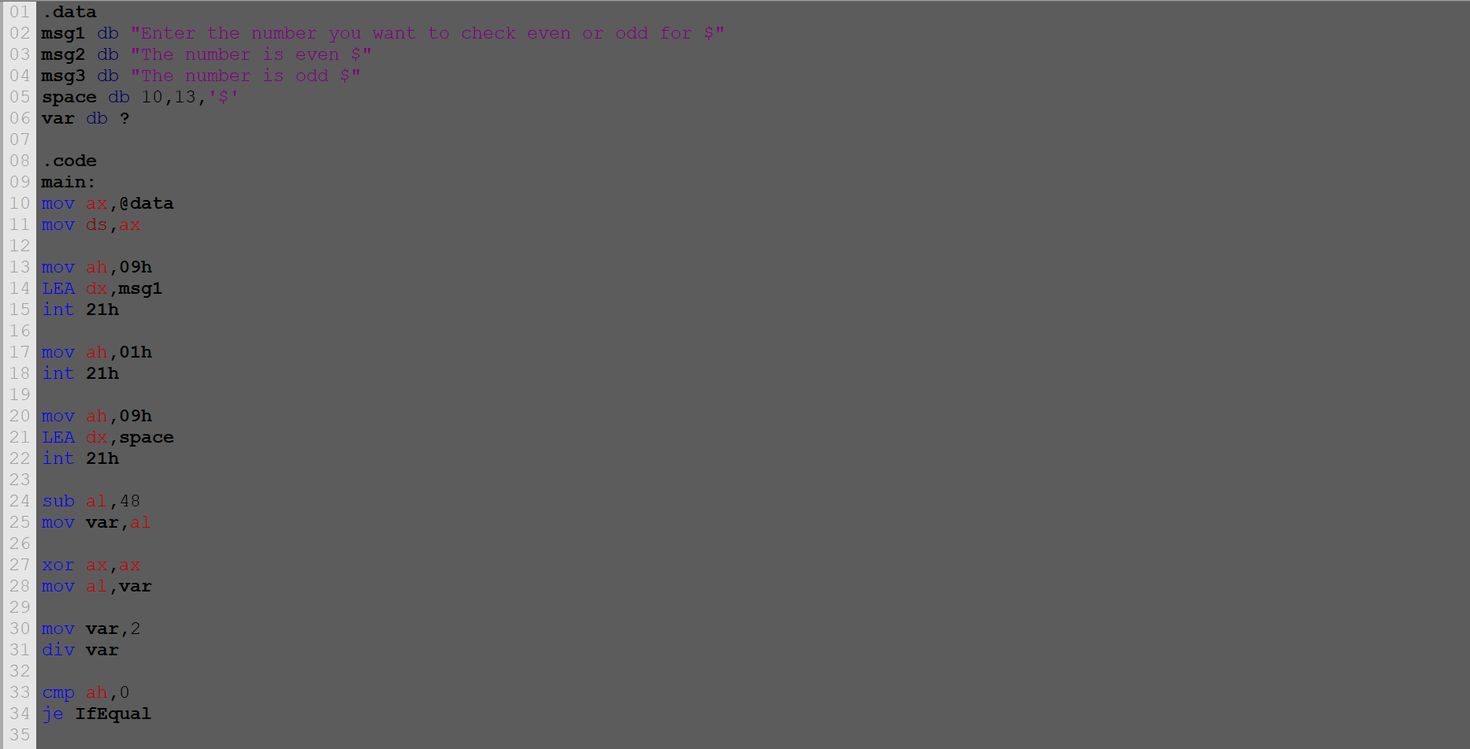

Screenshot (OUTPUT):

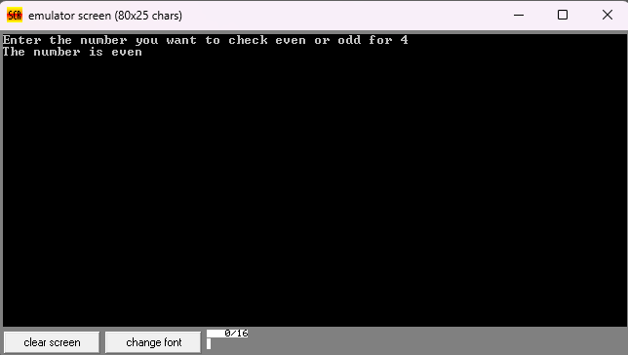

Task 2:
Code (TEXT):
.data

msg1 db "The grade is : $"
msg2 db "The number is invalid $"
number db 85

.code
main:
mov ax,@data
mov ds,ax

cmp number,0
jl Invalid

cmp number,100
jg Invalid

cmp number,49
jle Fgrade

cmp number,79
jle Cgrade

cmp number,89
jle Bgrade

mov ah,09h
LEA dx,msg1
int 21h

mov ah,02h
mov dl,'A'
int 21h

mov ah,4Ch
int 21h

Fgrade:

mov ah,09h
LEA dx,msg1
int 21h

mov ah,02h
mov dl,'F'
int 21h

mov ah,4Ch
int 21h

Cgrade:

mov ah,09h
LEA dx,msg1
int 21h

mov ah,02h
mov dl,'C'
int 21h

mov ah,4Ch
int 21h

Bgrade:

mov ah,09h
LEA dx,msg1
int 21h

mov ah,02h
mov dl,'B'
int 21h

mov ah,4Ch
int 21h

Invalid:

LEA dx,msg2
mov ah,09h
int 21h

mov ah,4Ch
int 21h

end main

Screenshot (CODE):
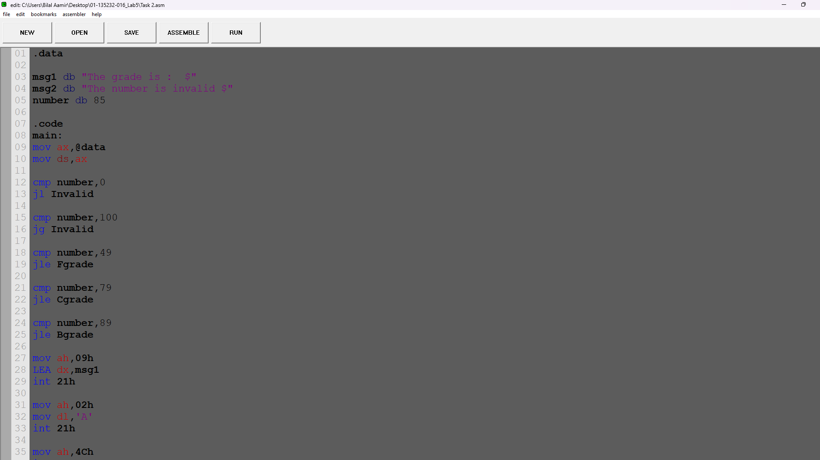

Screenshot (OUTPUT):
